Ameen Khan
2303605@sit.singaporetech.edu.sg
This report delves into the security vulnerabilities of OSPF, focusing on becoming a rogue OSPF router neighbour, its implications, and the defences against it. It provides details on the network attacks done, the outcomes of such attacks and mitigation measures one can take to prevent such attacks from succeeding.
Becoming a rogue router in OSPF Networks: Methods, impact, and Preventative Measures
ASSIGNMENT ON REAL-WORLD NETWORK ATTACKS AND DEFENSES, ICT2502C NETWORK SECURITY AY2023/24 TRIMESTER 3

Contents:
Introduction: 2
Theoretical explanation of the network attacks: 3
Summary: 3
Rogue Router Establishment: 3
False Link-State Advertisement DDOS and Propagation 5
Possible defences to these attacks: 6
OSPF Passive Interfaces [To Implement]: 6
OSPF Authentication with MD5 [To Implement]: 6
Access Control Lists (ACLs): 7
Route Filtering and Prefix List Validation: 7
Challenges faced when coding the script to make this attack successful: 8
OSPF state knowledge, especially EXSTART and EXCHANGE: 8
No prior knowledge of OSPF packet structure: 8
Very stringent age, sequence, options and flags hex fields in each OSPF packet type: 8
Instructions on lab network topology setup: 10
Procedure to demonstrate the attacks: 11
Procedure to implement the defences to defeat such attacks: 12
Wireshark captures of the malicious attack frames/packets: 13
Screenshots to show my network attacks are successful: 14
Screenshots to show my defence measures are successful: 17
References 20

Introduction:
OSPF is an Interior Gateway Protocol (IGP) that routes packets within a single autonomous system (also known as area) using link-state advertisements containing link-state information. The participating devices then construct a network topology map and make routing decisions by using the shortest-path-first algorithm to calculate routes.
OSPF as a routing protocol is widely used and deployed as it can converge a network in a matter of seconds. It has support for policies for route propagation, path load sharing and route importing. For me, as a network engineer overseeing Singtel’s Global Enterprise MPLS VPN Network, OSPF is widely used and implemented there, along with BGP, to quickly calculate routes and efficiently route traffic, while being smart enough to automatically recalculate routes should a link or node fault occur, minimising the impact to our operations (as opposed to us manually defining and deploying new routes). I also handled multiple OSPF-related incidents, some of which were due to improper OSPF configuration that caused the wrong route to be advertised. This gave me a lot of experience in understanding how OSPF works, and consequently, how to take advantage of certain mechanisms to gain a foothold and change the state of OSPF routing.
It also got me thinking: what if I could, by sending legitimate requests, masquerade as a legitimate router? We are taught in this project to mount some kind of attack using Kali Linux, but in the week that I spent finding attack tools (frostbits-security, 2018) that can be installed and run on Kali Linux, I found that 80% of the tools do not work. They are too old, with documentation created a long time ago like in 2014 (mad11970, 2014). And for the 20% that does work, all of them do attacks that I feel are not complicated enough, like flood OSPF link-state advertisements, which for example a tool called t50 (Pissarra, 2024) does. Plus, those tools send out invalid checksums so the router will not accept them anyway. Thus, I turned to scripting my own tool on my Kali Linux OS to successfully negotiate with a router in an OSPF area and be seen as a legitimate router. Essentially, become a rogue router using Scapy.
In preparation for this activity, I set up a Virtual Cisco lab at home, set up 2 virtual routers, configured them to use OSPF in the same area, captured all packets sent out in the ensuing exchange until their states turned FULL and used the packet capture information to understand and then reverse-engineer the entire exchange in Python Scapy.
Scapy (Scapy community, 2024) is a powerful interactive packet manipulation library written in Python. Scapy, when imported into my project, can forge, or decode packets of a wide number of protocols, send them on the wire, capture them, match requests and replies, and much more. The details of it are fully available on Scapy’s website, GitHub repository and their “readthedocs” (gpotter2, OSPF extension for Scapy, 2022) documentation. Their GitHub repository, especially the OSPF.py (gpotter2, OSPF extension for Scapy, 2022) code in the contributions folder, clearly define the elements that will construct the OSPF packet, how to form up each element with order into a packet, and the fields required in each of those elements, like flags and options.
This information was incredibly helpful since I found a preponderance of EIGRP attacks online (frostbits-security, 2018) but extraordinarily little material on OSPF attacks. What I found was attacks making false Link-State Advertisements, but they require the attacker to be in the middle of two routers, capture the LSAs they send to another, manipulate variables accordingly and send it out. What I wanted to do is to first become a rogue router and become “trusted”, with a FULL state reflected in the target router’s OSPF neighbour information so that I can bypass a lot of the alarms that my Enterprise network be generated by my network had I not established a relationship first. Essentially, use my Enterprise network’s security policies as a reference point and work around them to keep my attacks realistic.

Theoretical explanation of the network attacks:

Summary:
I am going to, through python code using the Scapy library, display my Kali Linux computer as a router to a target router and use OSPF packets to do the following:
- Move through the OSPF states starting from Init, followed by 2-Way, Exstart, Exchange, Loading and finally ending up as Full.
- Send the correct packet type as I move up through each state.
- Send each packet type in the correct format that Cisco devices expect.
- Parse the correct hexadecimal numbers for packet sequence, checksum, options, flag and other appropriate arguments for that format.
- Determine the correct router and/or link info to send back to the target, whether it is by echoing the info sent out from the target or crafting my own and pass that info correctly into the OSPF packet I send out.
- Monitor the responses from that router to see if it sends the next type of OSPF packet, ensuring that they accepted my responses and are ready for another response from me of another OSPF packet type.
- Launch a False Link-State Advertisement and see that it propagates throughout the OSPF area.

Rogue Router Establishment:
Below is an explanation of the OSPF states the target router will go through, and the actions my code will take in response to them:
- INIT – Target Router sends OSPF hello (Type 1) packets with OSPF broadcast IP address 224.0.0.5. My code will sniff for these packets and, when a packet from the target router is detected, sends a hello packet with the destination IP address of the target router.
  - I capture information about the router and store it in a text file on the desktop
  - I craft a hello packet in reply to what the target router expects.
  - I specify what my router ID is, my loopback address.
  - I specify the area ID I am in, which in this case I say is the same area as my target.
- 2-WAY – Target router sees hello packets from my device with the destination IP address as its own IP address.
  - The target router replies with a hello packet containing more information: the IP address of the designated router (the target router’s IP address for now), the IP address of the backup designated router (if any, zeroised for now) and the router ID of the active neighbour, which it decided is me
  - I reply to that with my own packet, but this time saying I am the designated router, I have no backup designated router and that the target router is my active neighbour.
- EXSTART – Target router, in reply to my hello packet, sends out a Database Description (Type 2) packet containing the capabilities of themselves.
  - I capture information from the target router’s DBD packet and store it in a text file on the desktop
  - I use 0x22 in the options field for the initial DBD packet I send out to signify Demand Circuits & External Routing Capability, matching the target router configuration in everything except Opaque and LLS Block, as I don’t want my rogue router to display that capability and then send more complicated packets.
  - I use 0x07 in the flags field for the initial DBD packet to signify Initial & More & Master, mirroring the target router configuration.
  - I had to research these fields online to understand what they mean and code matching arguments into my script. Certain fields of especial importance are:
    - Options – hexadecimal field to specify if the router supports certain capabilities. The capabilities of relevance to this project are:
      - O – Opaque LSA, specifies if the router supports Opaque LSAs which are used to carry additional information for future OSPF extensions or application-specific information, such as traffic engineering information in MPLS networks.
      - DC – Demand Circuits, specifies if the router supports demand circuits. Demand circuits allow OSPF to reduce the frequency of periodic Hello and LSA refresh packets on interfaces where such frequent exchanges are unnecessary, like on dial-up links.
      - L – LLS Data block, specifies that the DB Description packet contains an LLS data block at the end which allows routers to send additional data beyond the standard OSPF fields, such as graceful restart information, LSDB resynchronization requests, and checksum validation for packet integrity.
      - E – External routing, specifies if the router is capable of handling external routes (i.e., routes redistributed from other routing protocols). This option is commonly used for routers in Area 0 or non-stub areas, as stub areas do not accept external LSAs.
    - DBD Flags – hexadecimal field to specify the router’s current intentions in the OSPF neighbour adjacency establishment process. The flags of relevance to this project are:
      - I – Initial, Initial bit is set for the first DBD packet sent by the router for the DBD exchange.
      - M – More, More6 bit indicates that there are more DBD packets to follow in the current exchange.
      - MS – Master, Master bit identifies which router is the master and which is the slave in the DBD exchange.
- EXCHANGE – Target router sends out second set of DBD packets that are this time signifying what the router chooses for options and flags while also sending out link-state information held by the router.
  - I use 0x22 in the options field for the second DBD packet to signify Demand Circuits & External Routing Capability, matching the target router configuration in everything except Opaque and LLS Block, as I don’t want my rogue router to display that capability and then send more complicated packets.
  - I use 0x01 in the flags field for the second DBD packet to signify Master, stating that I am the Master in this Master/Slave OSPF relationship and that there are no “More” more DBD packets to follow, i.e. this is the last DBD packet I will send.
  - I sniffed each of the target router’s DBD packet’s link-state information and mirrored it back to it in my response DBD packet, showing it that I understood and will match the link-state information in my DB.
- LOADING – Target router exchanges link-state requests and updates with the rogue router containing all link-state advertisements.
  - I capture information from the target router’s DBD packet and store it in a text file on the desktop.
  - I send an OSPF Type 3 Link-State Request packet to my target router, specifying the target router’s Link State ID (its loopback address) as the one I am requesting link-state information from.
  - Target router replies with an OSPF Type 4 Link-State Update packet, containing the link-state information it has in its possession, which it shares with me in link-state advertisements.
  - My script sniffs the entirety of that link-state information and sends it back out in its own Type 4 Link-State Update packet, signifying that I have understood and saved that information in my database.
  - The target router may send out another Type 4 Link-State Update packet with newly tabulated link-state information, which I will sniff and send it back out in my own Type 4 packet to confirm it.
  - Once the target router is satisfied with the exchange, it sends a Type 5 Link-State Acknowledge packet, signifying that it acknowledged and is satisfied with all exchanges.
  - In reply, and as the master in this master/slave relationship, I send out one last Type 4 Link-State Update containing a Network Link State Advertisement to the entire OSPF area using the OSPF broadcast address 224.0.0.5. It informs all OSPF devices of mine and my target router’s presence in the OSPF network.
  - Then finally in reply, I acknowledge that acknowledge packet from the target router with my own Type 5 Link-State Acknowledge packet. It contains my link state ID as my port’s IP address and the advertising router as my device’s loopback address.
  - The target router replies with a Type 5 link-state acknowledge packet in reply, saying its own link state ID as its port’s IP address and the advertising router as its loopback address.
- FULL – Target Router signifies the OSPF neighbour relationship with my device, the rogue router, as FULL/DR, for full OSPF state and DR as Designated Router.
  - Now on, I send out a hello packet every 10 seconds to keep the FULL/DR OSPF state alive. The target router does the same.

False Link-State Advertisement DDOS and Propagation
Now, to do something additionally malicious, I will send 100,000 false link-state advertisements in multiple cpu threads to DDOS the target router’s link-state database.
While in the FULL/DR state and after 10 hello packets have been sent:
- Send 100,000 OSPF Type 4 link-state update packets containing a list of false Router Link-State Advertisements. These are fake links that do not exist.
- Target router acknowledges these links with a Type 5 Acknowledge Packet.
- Target router will flood this fake LSAs to all other OSPF adjacent routers, eventually filling the entire OSPF area with false link information update packets.
- PC1 and PC2 will report “Request Timed Out” as DDOS becomes successful.

Possible defences to these attacks:

OSPF Passive Interfaces [To Implement]:
The passive-interface command in Cisco when defining OSPF functionality is a defensive configuration option that can help protect a router from unauthorized OSPF neighbours and malicious OSPF attacks. In OSPF, interfaces are typically active, meaning they send out OSPF Hello packets to detect and form adjacencies (neighbour relationships) with other OSPF routers on the same network. The passive-interface command allows network administrators to specify that certain interfaces should not participate in OSPF neighbour discovery or adjacency formation.
When an interface is set as passive in OSPF, the router stops sending OSPF Hello packets on that interface and the router will not form OSPF adjacencies on that interface, effectively making it invisible to other OSPF routers for neighbour establishment. However, the network connected to the passive interface can still be advertised in the OSPF routing protocol, so other routers in the OSPF area can reach it.
Should the target router set the interface facing me as a passive interface, the interface does not send Hello packets and script won’t be able to initiate the OSPF neighbour relationship needed to start the handshake process. Furthermore, the target router will ignore any OSPF messages from my script, effectively blocking all attempts to influence the OSPF routing process from that interface.

OSPF Authentication with MD5 [To Implement]:
OSPF (Open Shortest Path First) authentication is a security mechanism used to ensure that only authorized routers can participate in the OSPF routing process and exchange OSPF messages. MD5 authentication is a widely used option that provides a stronger level of security compared to simple plaintext passwords.
Message Digest 5 (MD5) is a cryptographic hash function that generates a 128-bit hash (or "digest") of a message. With OSPF MD5 authentication, each OSPF message sent over an interface includes an MD5 hash of the packet content and a shared secret key. The MD5 digest is appended to each OSPF message, and only routers with the correct shared key can authenticate and process these messages. This prevents unauthorized routers from establishing an OSPF adjacency, sending LSAs, or interfering with the routing process, as they cannot produce the correct MD5 hash without knowing the key.
MD5 authentication in OSPF effectively counters Spoofing as Attackers cannot easily inject fake OSPF packets or modify existing ones because they cannot generate the correct hash without knowing the MD5 key. It also effectively counters Man-in-the-Middle attacks because, even if an attacker intercepts OSPF traffic, they cannot alter the packets without invalidating the MD5 hash, making it difficult to inject or modify routes in real time. Also, if the MD5 key is sufficiently long and complex (e.g. 12+ character alphanumeric key with special characters), Brute-forcing the MD5 key is theoretically possible but generally infeasible with a strong key, as the time and computational power required to brute-force would exceed practical limits.

Access Control Lists (ACLs):
Access Control Lists (ACLs) are a set of rules that network devices like routers and switches use to filter and control incoming and outgoing network traffic based on various criteria. ACLs are used to enhance security by explicitly permitting or denying traffic based on Source and destination IP addresses, Protocol type (e.g., TCP, UDP, OSPF), Port numbers (for TCP/UDP traffic), Direction of traffic (inbound or outbound) or Interface where the traffic is entering or leaving.
ACLs can defend against OSPF attacks by filtering based on source IP, protocol, and interface, which can prevent unauthorized OSPF packets (e.g., Hello packets, LSAs) from reaching the router’s OSPF process. This means my attack script's attempts to initiate OSPF communication, create OSPF Neighbour Relationships and inject false LSAs would be blocked, Reducing the target router’s Attack Surface to potential OSPF attacks.
You can enact this with a config statement like “access-list 100 permit ip 10.0.0.0 0.255.255.255 any” only allowing ip addresses from 10.0.0.0/24 to talk to the router, preventing OSPF neighbour states from being established from an ip address like 192.168.10.99 but it prevents any kind of IP traffic too, which in this case we do not want.

Route Filtering and Prefix List Validation:
Route Filtering and Prefix List Validation are mechanisms used to control and validate routing information received from peers or other routers. They help ensure that only legitimate routes are accepted and propagated within a network. Both techniques can effectively counteract routing attacks by validating the received routes and filtering out suspicious or unauthorized prefixes.
Route Filtering allows network administrators to control which routes are advertised or accepted by a router based on certain criteria, such as IP prefixes, route sources, or protocol type. This filtering can be applied for Inbound Filtering - Controls the routes that a router accepts from its neighbours, and Outbound Filtering - Controls the routes that a router advertises to its neighbours.
In the context of OSPF, route filtering helps defend against malicious route injection by preventing unauthorized or unexpected LSAs (Link-State Advertisements) from being accepted. For instance, a filter could allow only LSAs for specific known networks, ignoring LSAs for unauthorized or suspicious networks injected by an attacker. Also, by applying outbound route filters, a router can ensure that it only advertises legitimate routes to its peers. This can stop malicious routes from spreading to other routers in the network. Furthermore, filtering out unnecessary or suspicious LSAs reduces the OSPF database size, limiting the effect of any LSA flood attacks.
You can enact this with a config statement like “ip prefix-list OSPF_PREFIXES seq 5 permit 10.0.0.0/8 le 32”, restricting OSPF to only accepting packets and routes within the 10.0.0.0/8 prefix, making it better than the ACL statement quoted earlier as it means only OSPF packets not from 10.0.0.0/8 will be denied, not other types of packets.

Challenges faced when coding the script to make this attack successful:

No prior knowledge of OSPF packet structure:
When starting this project, I studied and passed my CCNA, so I know how OSPF relationships work, how to configure routers to establish OSPF relationships and routing as opposed to manually configuring default routes and to do show commands to see the success of a router’s OSPF relationships and the extent of an OSPF area and the routes within them that the router now knows.
I had no prior experience of how OSPF packet structure works. The OSPF packet must be formed in a specific way and encapsulated properly and with a checksum generated to form a legitimate packet that the target router might recognise and accept. I had to study Scapy’s GitHub code to craft each packet properly so that they were in alignment to RFC 2328 and acceptable to my Target router.

OSPF state knowledge, especially EXSTART and EXCHANGE:
When trying to reach a FULL/DR OSPF relationship between the target router and my Kali Linux, I encountered a situation where the OSPF relationship on the target router failed to progress beyond the EXSTART / EXCHANGE state. This state indicates that the routers were attempting to exchange Database Description (DBD) packets but were unable to fully synchronize their link-state databases and establish an adjacency. Being stuck in this state prevented the routers from reaching the FULL state, where they would normally be able to exchange routes effectively.
The reason for all this was because I had yet to understand how the Options, Flags and Sequence fields had to be defined in DBD Type 2 packets during EXSTART and EXCHANGE. I had to define my Options as 0x22, signifying that my router was capable of DC – Demand Circuits and E – External Routing. I had to study the RFC 2328 OSPF v2 document from the Internet Engineering Task Force, capture packets using Wireshark from my Target Router to another legitimate router when they went through each stage of the OSPF exchange and study the field values defined in each stage, map all that to the IETF RFC 2328 document, went over my CCNA material for OSPF to map it to what I was observing on Wireshark and study Scapy’s GitHub code to craft each packet properly so that they were in alignment to RFC 2328 and acceptable to my Target router.
It took a few days because I was starting from zero knowledge about DBD packet crafting, but I managed to resolve that issue and allowed the target router to move up the OSPF neighbour states to become FULL/DR.

Very stringent age, sequence, options and flags hex fields in each OSPF packet type:
The OSPF packet contains fields like sequence, options, age and flags in each type of packet, type 1 through 5. These fields need to be manipulated in a certain way according to each type so that the target router understands and believes what we are saying.
During EXSTART and EXCHANGE, the master router should increment the DD sequence number with each new DBD packet it sends during the exchange, which the slave router echoes when it receives from the master, not increment it. I had to code that into my script. I also had to send the first DBD packet with the I-bit (Initial) set. I also had to set the M-bit to denote More, more DBD packets coming, and unset it at the last exchange, and set the MS-bit to denote that I am the master in this master-slave relationship. Also, as the master, I must increment the DBD Sequence number every time I have to send one, because as the master I increment the DBD sequence number in the packet and the slave just echoes the same number back.
During the EXCHANGE and LOADING states, Link-State Advertisements or LSAs are exchanged, either in DBD Type 2 packets or Link State Update Type 4 packets. Here, sequence number is incremented differently. It is incremented each time a new instance of the LSA is generated, ensuring that routers replace old information with newer updates. The age number of the LSA should also be incremented appropriately as the LSA is propagated and changed to 1 if there is a new LSA created.
After considering and accounting for such changes in my script, only then could I achieve FULL/DR neighbour state with the target router.

Instructions on lab network topology setup:
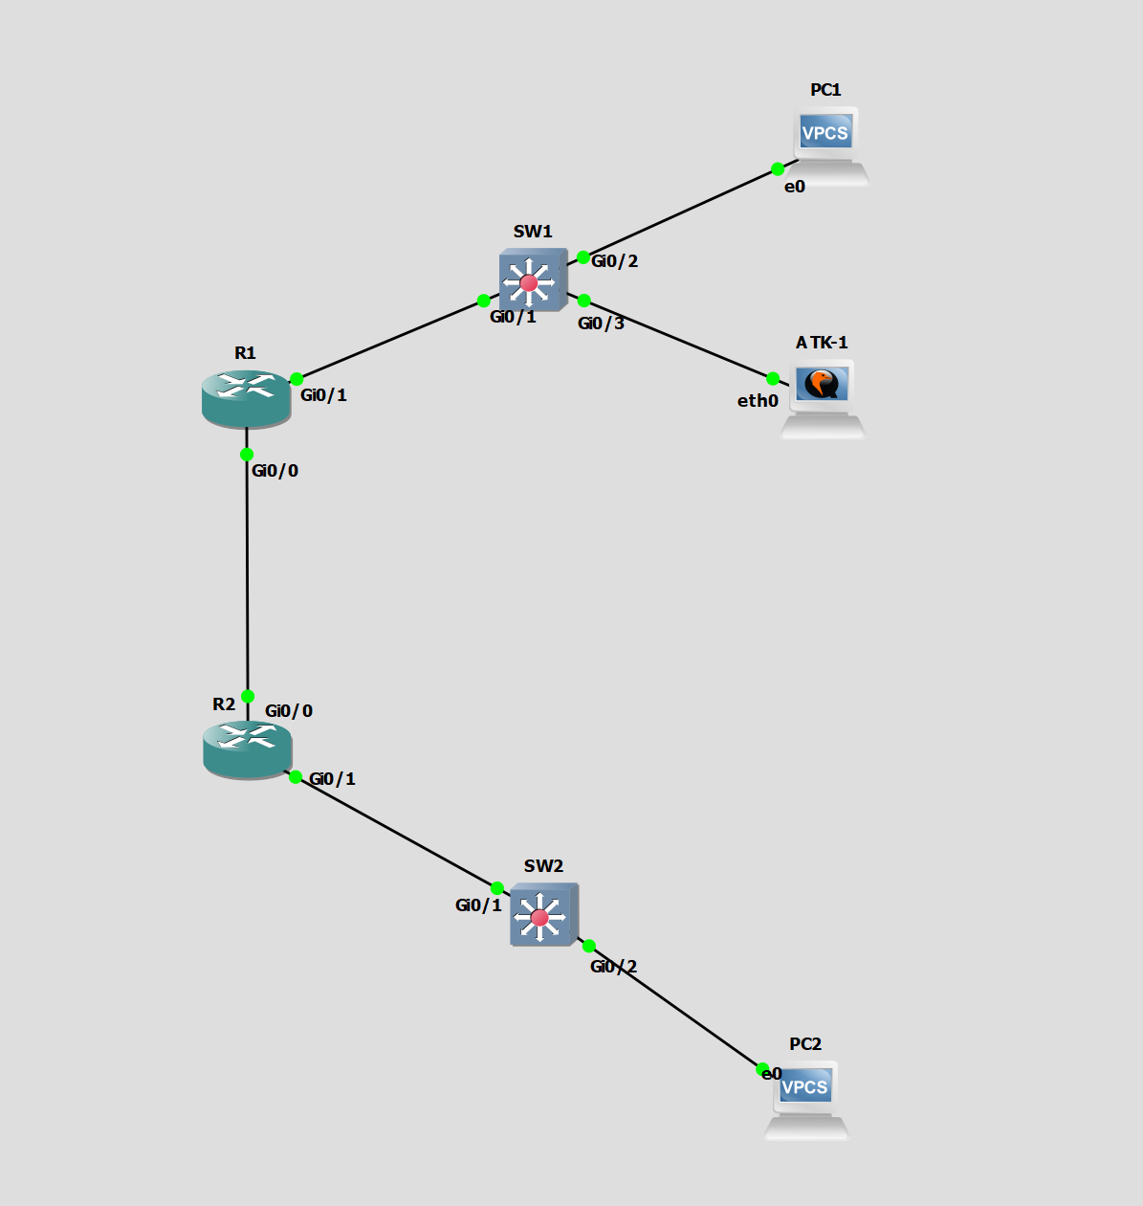
As this is from GNS3, for the real-life deployment, please take note that every interface has an extra /0 in the middle (e.g. Gi0/1 -> Gi0/0/1)
Also, PC1 and PC2 are host PCs which are optional but do not play a role in the attack. ATK-1 is the Kali Linux PC, connected like a host PC but will masquerade as an OSPF router.
We will need 2 routers, 2 switches and 1 Computer with Kali Linux running to conduct the attack.

Procedure to demonstrate the attacks:
- Connect and power all devices as shown in the topology diagram, following the notes at the bottom.
- Load both network devices with the corresponding configuration in the attached device config text files, copying and pasting the config text into the router cli.
- Start-up Kali Linux OS
- Connect to the network switch SW1 with the provided port, in this case it is SW1 Gi0/0/3. Take note of Kali Linux ethernet port name that was used (e.g. eth0, eth1)
- Set the ethernet port IPv4 settings method to manual and the IP address as 192.168.10.99, netmask as 24 and Gateway as 192.168.10.1
- Add the script to the desktop of Kali Linux, if not done already.
- Start Wireshark and filter to OSPF packets to observe the attack happening
- Open Terminal Emulator and input the following: sudo python3 ~/Desktop/ospf_lsa_12345pxr.py
- Observe the attack happening.

NOTE: If router does not display neighbour relationship as FULL/DR or if there are other complications, CTRL+C to cancel the script and then run it again.

Procedure to implement the defences to defeat such attacks:
As spoken earlier, I will implement OSPF passive interfaces and OSPF MD5 Authentication in the target router:
passive-interface gi0/0/1
ip ospf authentication message-digest
ip ospf message-digest-key 1 md5 Cisco_Rockz_902!0
- Do erase startup-config on R1 and R2
- Reload R1 and R2
- Load new config from config text files with the last word being “G”
- Run the attack script again and observe what happens.

Wireshark captures of the malicious attack frames/packets:
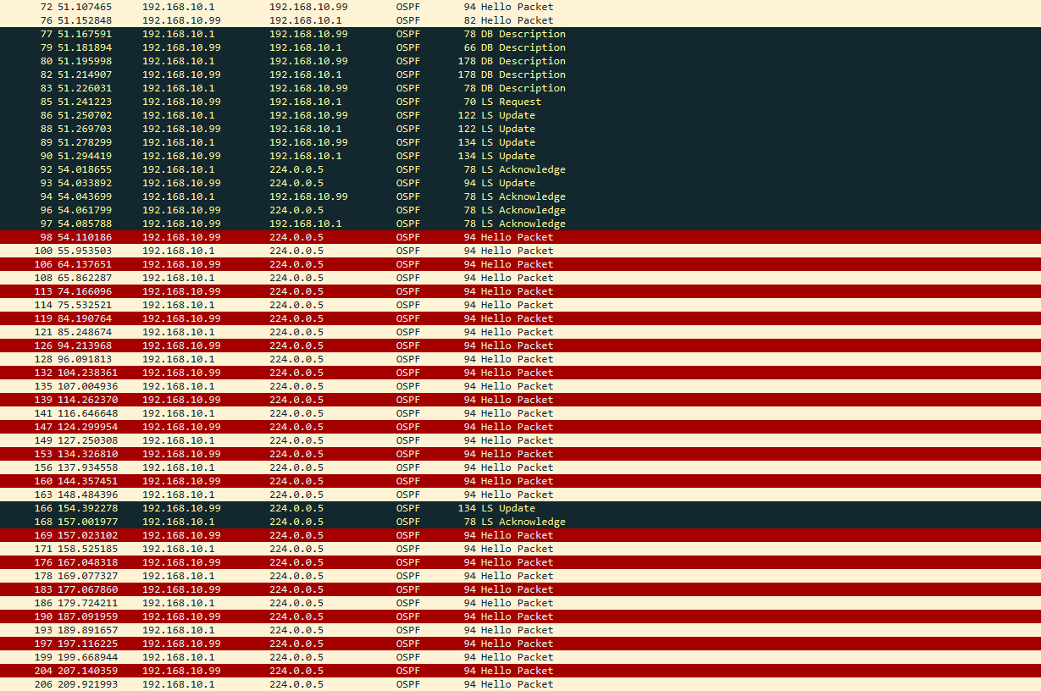
Wireshark capture between Kali Linux 192.168.10.99 and R1 192.168.10.1, receiving R1 OSPF hello packets and establishing a FULL/DR neighbour relationship with it. At 166, the LSA poisoning script starts and R1 acknowledges the LS Update packet.
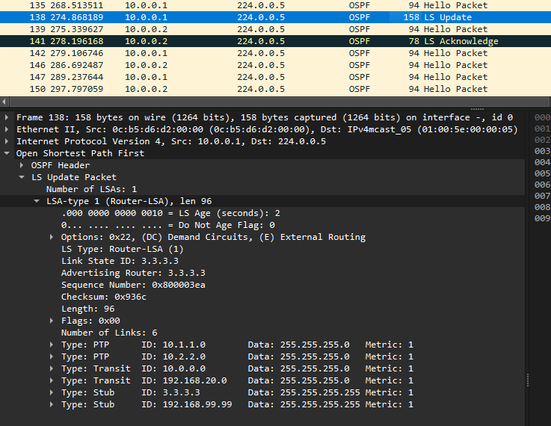
Wireshark capture showing the LSA poisoning propagation of fake links from R1 receiving from Kali Linux attack PC and being propagated from R1 to R2, with R2 acknowledging.

Screenshots to show my network attacks are successful:
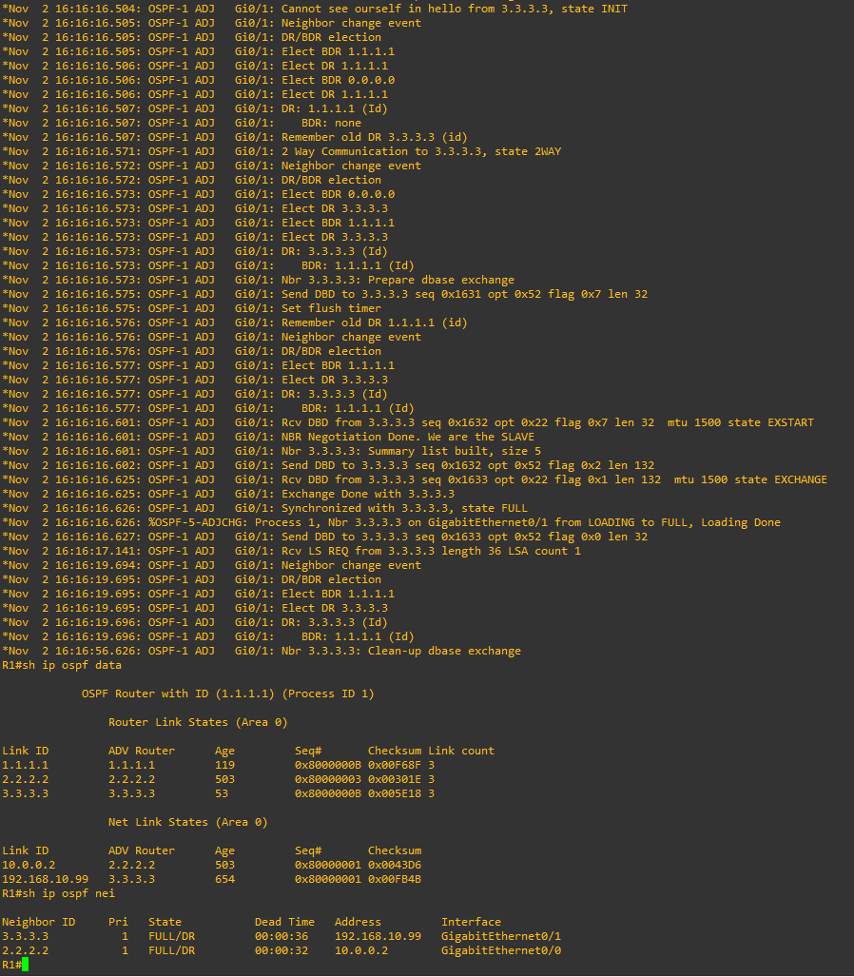
Screenshot of R1 cli showing successful exchange between R1 1.1.1.1 and rogue router 3.3.3.3, achieving FULL/DR state with no debug ospf errors shown.
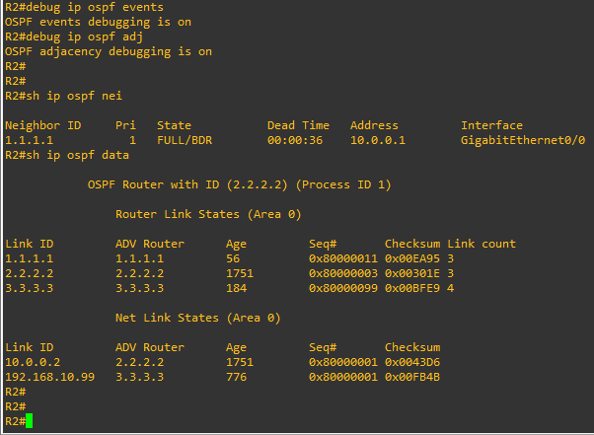
Screenshot from R2 2.2.2.2 showing rogue router 3.3.3.3 being registered in the OSPF area 0 database following FULL/DR state with R2
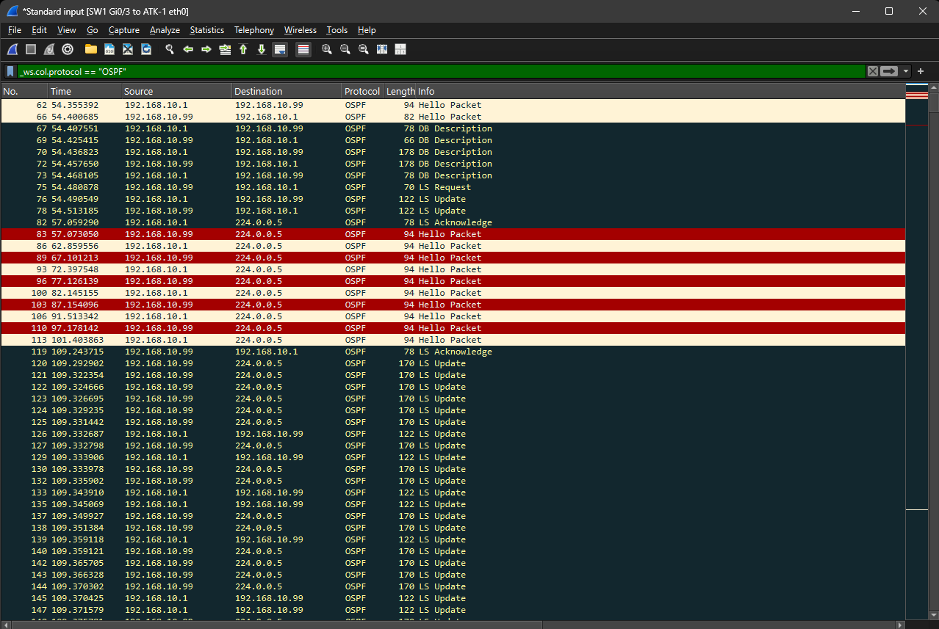
Screenshot from Wireshark showing script starting, progressing through states and achieving FULL state, then LSA poison DDOS being sent and then receiving acknowledgement (Poison_Prop Propagated) from R1 about the poison Link-State Update

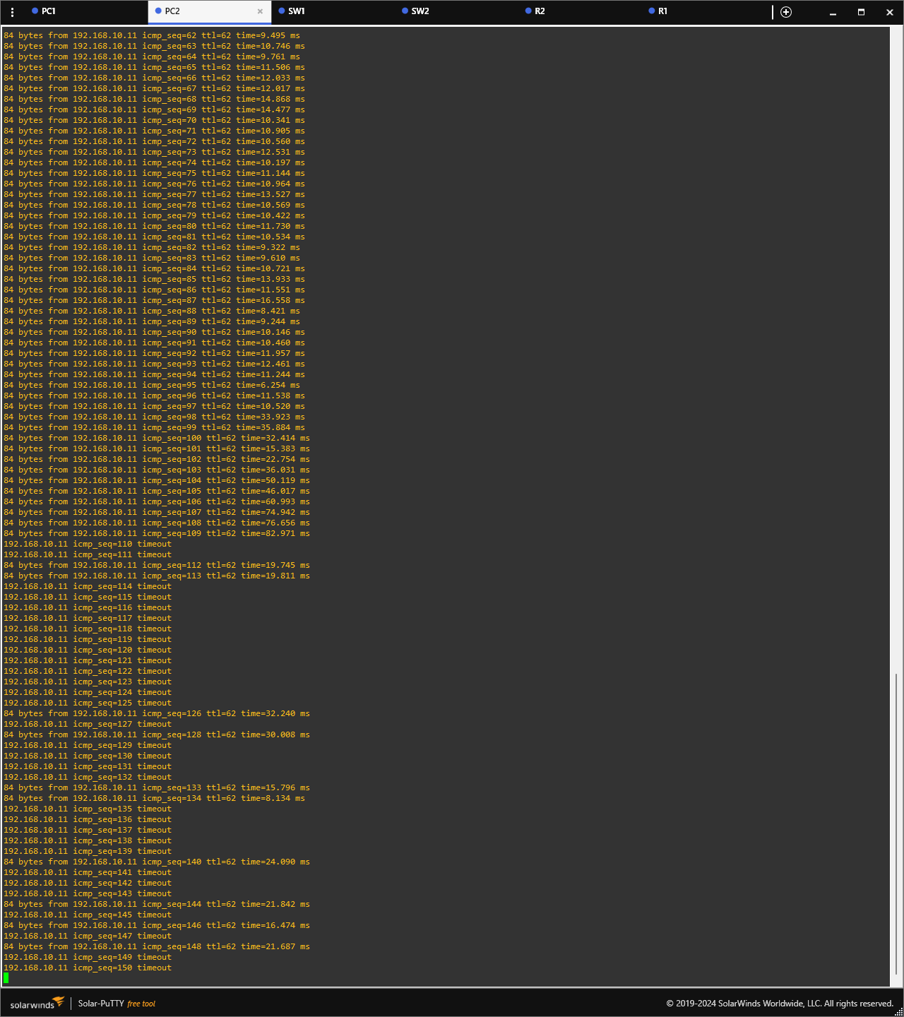 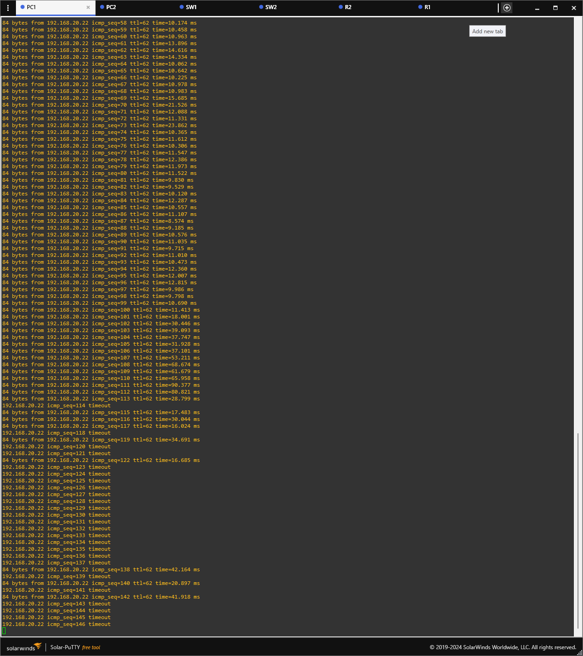
Screenshot from PC1 and PC2 cli showing DDOS worsening ping and then ruining it entirely.

Screenshots to show my defence measures are successful:

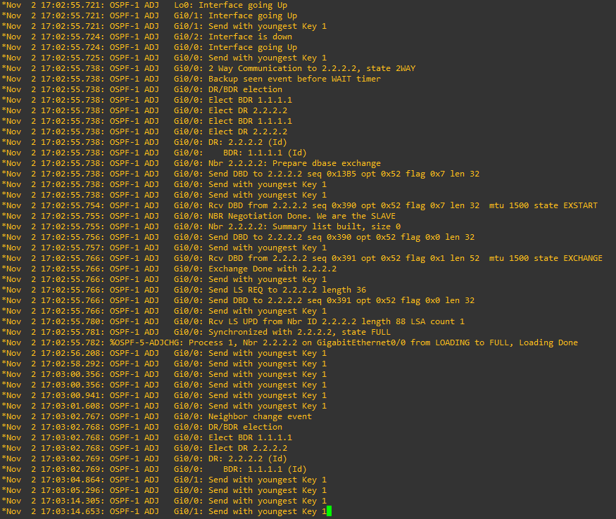
Screenshot from R1 1.1.1.1 showing it can achieve OSPF adjacency and FULL state with R2 2.2.2.2 when OSPF Authentication with MD5 is implemented.

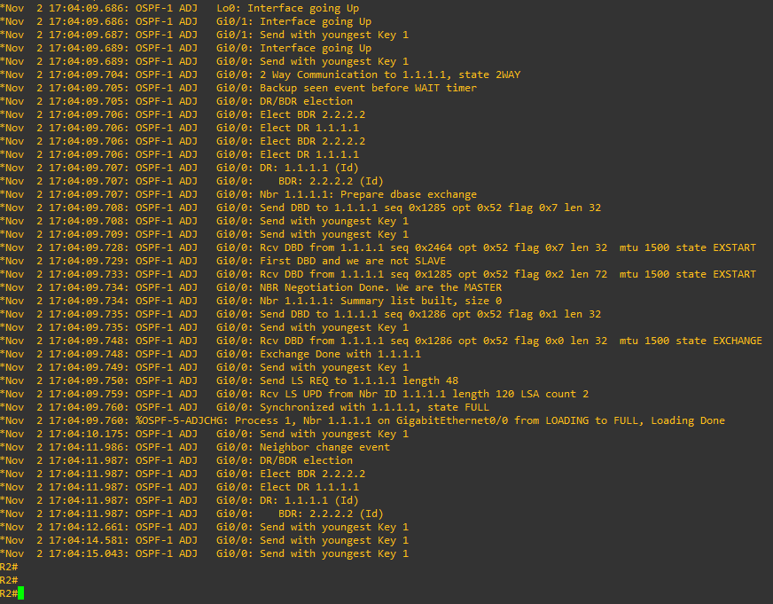
R2 showing the same, achieving FULL adjacency with R1 when OSPF Authentication with MD5 is enabled

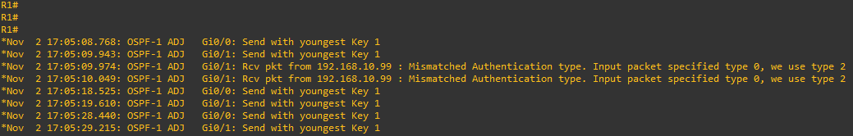
Screenshot from R1 showing that my attack script has no Authentication along with Type 0 Authentication (none), my script fails to establish adjacency and move up through the OSPF states.

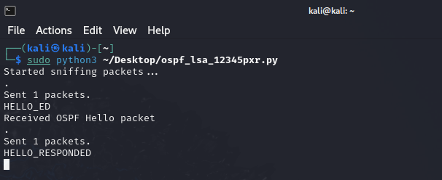
My script failing to establish adjacency and move up through the OSPF states, stuck at Hello_Responded.

References
(Raizo62), D. A. (21 July, 2024). Loki_on_Kali. Retrieved from Github: https://github.com/Raizo62/Loki_on_Kali
Arhont Information Security Ltd. (11 March, 2024). cisco-torch. Retrieved from Kali.org: https://www.kali.org/tools/cisco-torch/
frostbits-security. (18 December, 2018). MITM-cheatsheet - All MITM attacks in one place. Retrieved from Github: https://github.com/frostbits-security/MITM-cheatsheet
gpotter2. (5 July, 2022). OSPF extension for Scapy. Retrieved from Github: https://github.com/secdev/scapy/blob/master/scapy/contrib/ospf.py
gpotter2. (2022). OSPF extension for Scapy. Retrieved from Read the Docs: https://scapy.readthedocs.io/en/stable/api/scapy.contrib.ospf.html
HackTricks Researchers. (21 August, 2024). Pentesting Network. Retrieved from HackTricks: https://book.hacktricks.xyz/generic-methodologies-and-resources/pentesting-network
IETF | Internet Engineering Task Force. (April, 1998). RFC 2328 OSPF Version 2 April 1998. Retrieved from IETF | Internet Engineering Task Force: https://www.ietf.org/rfc/rfc2328.txt
Ishiguro, K. (23 September, 2024). FRRouting. Retrieved from FRRouting Project: https://frrouting.org/
mad11970. (18 January, 2014). Installing loki on kali linux 32 bit. Retrieved from Kali Forums: https://forums.kali.org/archived/showthread.php?20003-Installing-loki-on-kali-linux-32-bit
Magama Bazarov, <. (30 January, 2024). Above: Invisible network protocol sniffer. Retrieved from GitLab: https://gitlab.com/kalilinux/packages/above
necreas1ng. (2017). Routing nightmare. How to pentest OSPF and. Retrieved from HackMag: https://hackmag.com/security/routing-nightmare/
Ouamer, M. (7 November, 2022). OSPF TTL Security Check Explained: Operation, Example, and Configuration. Retrieved from ITSkillBuilding.com: https://itskillbuilding.com/networking/network/ospf/ospf-ttl-security-check/
Pissarra, F. L. (4 August, 2024). t50 - mixed packet injector tool. Retrieved from GitLab: https://gitlab.com/fredericopissarra/t50
Scapy community. (28 September, 2024). Scapy: the Python-based interactive packet manipulation program & library. Retrieved from Github: https://github.com/secdev/scapy
threat9. (18 October, 2018). RouterSploit - Exploitation Framework for Embedded Devices. Retrieved from GitHub: https://github.com/threat9/routersploit

